Study Guide / Science Test 04/13

How do plants reproduce? What factors affect germination rate?

1. What is the main role of colored markings on the flowers of a flowering plant?

_________________________________________________________________________

2. What is the order of events in the life cycle of nonflowering and flowering plants?

_________________________________________________________________________

3. Which stage is found in the life cycle of flowering and nonflowering plants?

_________________________________________________________________________

4. Why are bees important for the reproduction of plants?

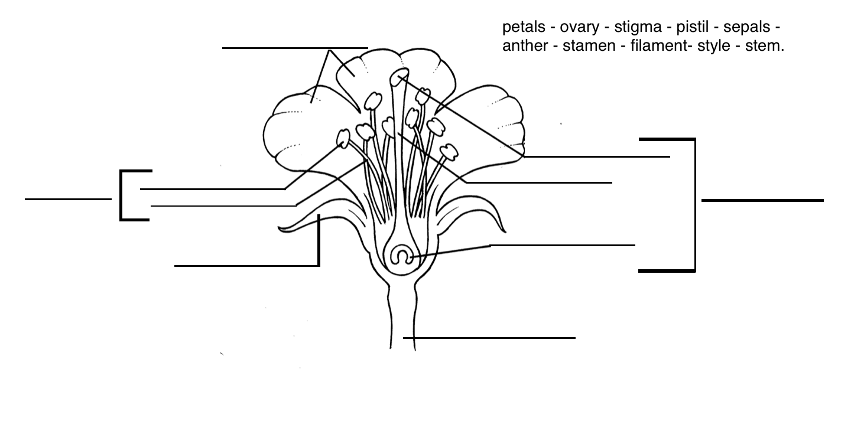
_________________________________________________________________________

5. Which feature of a plant is used for sexual reproduction?

_________________________________________________________________________

6. What is one experiment we can do to test if bean seeds need soil to germinate?

_________________________________________________________________________

7. How often should you water a seed if we want it to germinate faster?

_________________________________________________________________________

8. Name the female and male parts of a flower:

_________________________________________________________________________

9. Label the parts of the flower below:

Study Guide / Science Test 04/13

How do plants reproduce? What factors affect germination rate?

- What is the main role of colored markings on the flowers of a flowering plant? To attract insects to carry pollen.

2. What is the order of events in the life cycle of non flowering and flowering plants? 1) seed, 2) pollination, 3) seed dispersal, 4) fertilization.

3. Which stage is found in the life cycle of flowering and non flowering plants? They both make seeds.

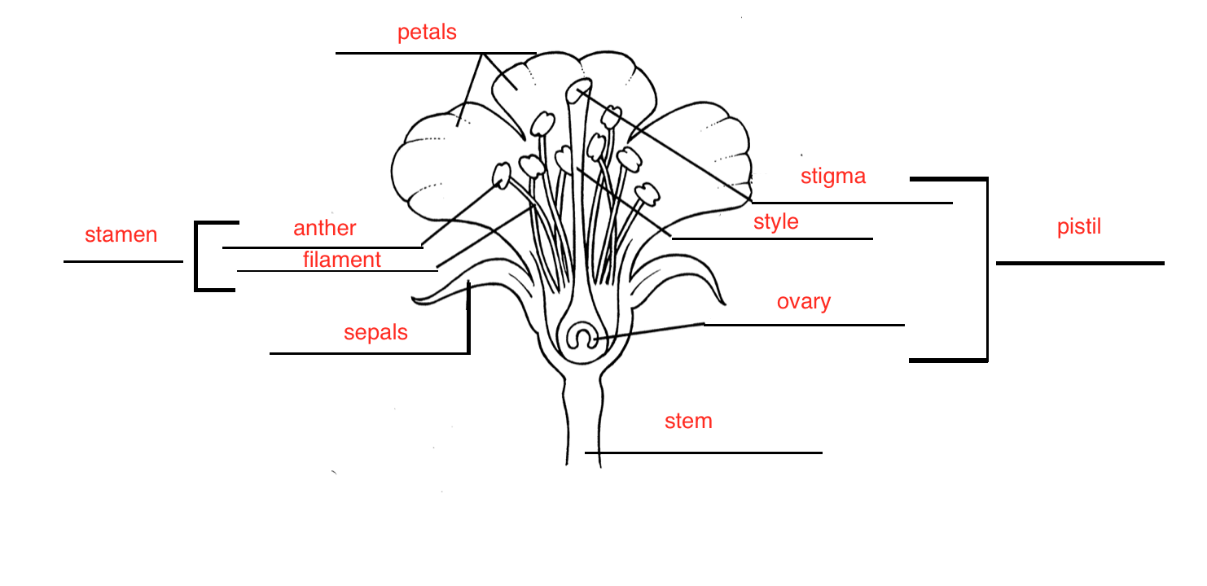
4. Why are bees important for the reproduction of plants? Bees play an important role as plant pollinators.

5. Which feature of a plant is used for sexual reproduction? flower

6. What is one experiment we can do to test if bean seeds need soil to germinate? We can place a bean seed in a plastic bag with a paper towel and water to see if it will germinate.

7. How often should you water a seed if we want it to germinate faster? Twice a day.

8. Name the female and male parts of a flower: stamen ( male) / pistil ( female)

9. Label the parts of the flower below:

