Franklin Academy
4th Grade
Science Fair

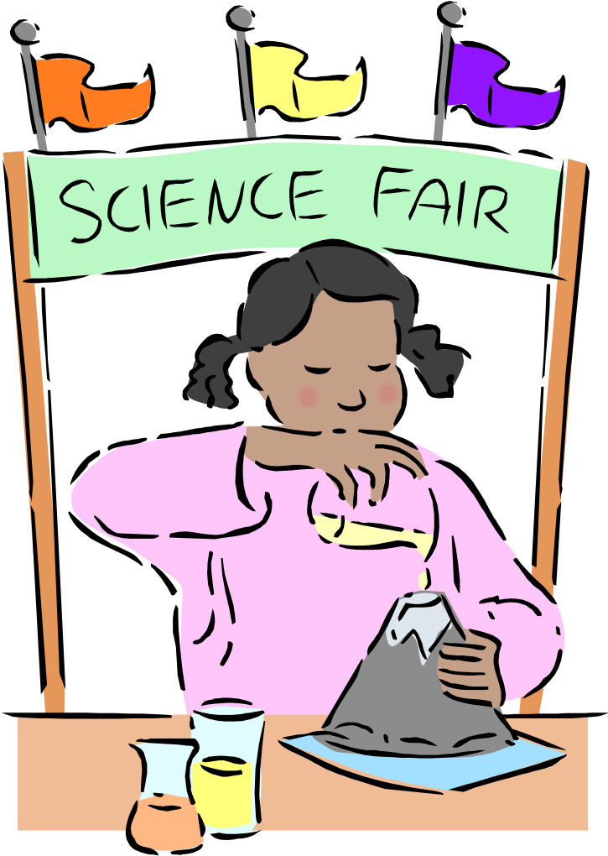

Dear Parents/Guardians:
We are excited about the interest in this year’s Science Fair, which will take place on Thursday, June 1, 2018. We want to share with you the following important information.

A comprehensive packet accompanies this letter. Kindly read it with your child so both of you understand the purpose for and the process of the project. If you have any questions, please express them to your child’s teacher.

We want our budding scientists to have fun and to be safe. It is strongly advised that you supervise any experiments; especially those involving chemicals, electricity, or that require sharp tools. Always insist upon safety gear. These precautions will assure that your child’s inquiry into the magnificent world of science is safe.

As your child progresses through the scientific method of inquiry, here are a few suggestions:
- Be sure that your child keeps a Science Folder with one pocket on each side. In one pocket, he/she should have the Science Fair Project Packet. In the other pocket, he/she should have their Science Fair Planning Form.
- Experiments that involve plants or animals must start soon so schedule deadlines are met.
- Students may type the information that will go on the Science Display Board, if they wish. If they wish to write it, it must be very neat and they must print, no cursive please.

- Students may also enhance their project by using the computer for illustrations (in the form of tables, graphs, clip art, etc.); however, they must include at least 2 student made illustrations.
- Finally, we encourage parental assistance; however, WE DO NOT SUPPORT parents doing the project for their child. The students will be presenting their experiment in class and they will have to answer questions about their project. Remember, it is the student’s project; we want him/her to take responsibility for it. Be there to help prioritize activities and effectively manage their time.

Please be sure to sign and return the following page to your child’s teacher as soon as possible.

Thank you for your encouragement and support. We are certain that all children will have an everlasting learning experience because parents and teachers are so committed to working together for success.

Due Dates

Friday, May 4: Title & Problem Statement
Hypothesis
Monday, May 7: List of Materials List of procedures

Students should be starting and conducting their experiments

Friday, May 25: Results
Data and Conclusions
Summary/Abstract
Applications/Recommendations
Acknowledgements and Bibliography

Students should be putting their display boards together as they are working on the project.

Projects are due in class, ready to be presented, on Friday, June 1, 2018.
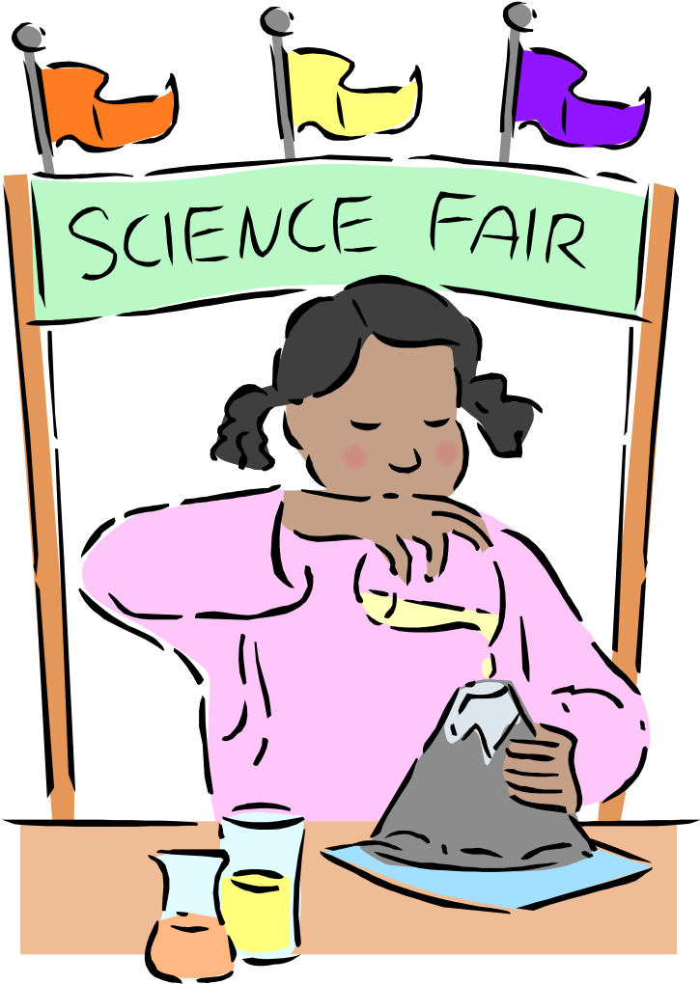
Science Fair Contract

- I understand that my child must complete a Science Fair Project and that failure to do so will seriously affect his/her Science grade in the fourth quarter.

- I am aware that I may assist my child in his/her project; however, parents are not allowed to do the project for their child in any way. They may not conduct the experiment for the child or write any part of the report for them.

- I also understand that it is very important that my child turns in each part of the project on its due date. Also, if the teacher requires that any corrections be made to a part of the project, those corrections are due on the following school day.

- I understand the due dates are as follows:

Friday, May 4th: | Title & Problem Statement  Hypothesis
Monday, May 7th: | List of Materials  List of procedures

Students should be starting and conducting their experiments

Friday, May 25th: | Results  Data and Conclusions  Summary/Abstract
Friday, May 25th: | Applications/Recommendations  Acknowledgements and Bibliography

Projects are due in class, ready to be presented, on Friday, June 1, 2018

Parent Signature & Date: ___________________
Please keep the copy attached for your records and turn in this sheet, signed, and date

Grading Guidelines

Attached are the rubrics that will explain, in detail, what the science fair project must include. Below are some other tips and helpful suggestions:

- Remember that a good project is planned and developed over a period of time. Start planning now!!
- Display boards may be purchased at Target, Wal-Mart and craft stores.
- When the experiment is presented, the display board will be used as a visual aide, so be sure the information is LARGE enough for the whole class to see. Be ready to answer questions from the class and the teacher.
- The entire Science Fair project will be worth 3 grades (project grade, 2 classwork grades):
  - Science Folder: Students must have all parts of the Student Science Fair Planning Form complete, neatly written, and work must be done by the student. Each part must be turned in on its due date or points will be deducted, as per the teacher’s discretion.
  - Written Report (see attached rubric)
  - Display Board (see attached rubric)
  - Oral Presentation (see attached rubric)

Science Fair Display Board
Rubric

- Title: The title is phrased as a question _____ 5 points

- Problem Statement/Purpose: One or two sentences written on the display board telling what you studied. Tell why you picked your topic ____ 10 points

- Hypothesis: One sentence written on the display board. It tells how you think the problem can be solved. ____ 10 points

- Materials: All materials listed on the display board, including amounts (1/2 cup)
____ 5 points

- Procedure: Tell what you did sequentially (step by step) ____ 20 points

- Results: Tell what actually happened ____ 10 points

- Conclusions: Did your results prove or disprove your hypothesis? Write a brief summary. ____ 10 points

- Neatness and Appearance: Your Science Fair display board and visual display (sample experiment) should be neat and well organized.
____ 10 points

- Difficulty/Creativity: The project should be appropriate for the grade level and a challenge for the student.
_____ 10 points
- Independently Completed: All work is completed by the student
_____ 10 points

Total points ________ / 100 points

Science Fair Written Report and Oral Presentation
Rubric (2 grades will be awarded based on this rubric)

- Title: The title is phrased as a question _____ 5 points

- Problem Statement/Purpose: One or two sentences written on the science fair Science Fair Planning Packet telling what you studied. Tell why you picked
your topic _____ 10 points

- Hypothesis: One sentence written on the Science Fair Planning Packet.
It tells how you think the problem can be solved. _____ 10 points

- Materials: All materials listed in the Science Fair Planning Packet, including
amounts (1/2 cup) _____ 5 points

- Procedure: Tell what you did sequentially (step by step) _____ 10 points

- Summary/Abstract: A summary of your science fair project. Why did you choose this project, what is the project about; what do you hope to find out?
_____ 10 points

- Acknowledgements/Bibliography: Who do you want to thank? ____ 5 points

- Data: graphs, pictures, charts, surveys, drawings, etc. _____ 10 points

- Conclusions: Did your results prove or disprove your hypothesis?
_____ 10 points

- Application: How can your project benefit others? How can your project be
applied in a real life situation. _____ 10 points

- Difficulty/Creativity: The project should be appropriate for the grade level and a challenge for the student. _____ 5 points

- Independently Completed: All work is completed by the student. The paper is free of spelling and grammar mistakes. Student conveys information concisely and informatively during presentation.
_____ 10 points

Total points ________ / 100 points

My Science Fair
Planning Packet

Student Science Fair Planning Form

Name _______________________

- Use this form to go step by step through the Scientific Method in order to successfully complete your Science Fair Project. It is very
important that you meet all due dates.
Deadlines will be strictly enforced.

- This packet goes on the right side of your Science folder. On the left side, you should have your Science Fair Project Packet.

- If you lose this, you will have to start all over again, so be sure to keep it in your Science Folder and always be sure of where you have placed your Science Folder.

TITLE ___________________________

PROBLEM STATEMENT
______________________________________
______________________________________
______________________________________

HYPOTHESIS
______________________________________
______________________________________
______________________________________
______________________________________
______________________________________
______________________________________

MATERIALS
______________________________________
______________________________________
______________________________________
______________________________________
______________________________________
______________________________________

PROCEDURE Number the steps, bullet them, or use transition words (first, second, third, next last, etc.) and skip lines.
______________________________________
______________________________________
______________________________________ ______________________________________ ______________________________________
______________________________________
______________________________________
______________________________________
______________________________________
______________________________________ ______________________________________ ______________________________________
______________________________________
______________________________________
______________________________________
______________________________________ ______________________________________ ______________________________________
______________________________________
______________________________________
______________________________________
______________________________________

SUMMARY/ABSTRACT
______________________________________
______________________________________
______________________________________
______________________________________
______________________________________
______________________________________ ______________________________________ ______________________________________
______________________________________
______________________________________
______________________________________
______________________________________
______________________________________ ______________________________________ ______________________________________
______________________________________
______________________________________
______________________________________
______________________________________
______________________________________ ______________________________________
______________________________________

BIBLIOGRAPHY All 4th grade students will have one. You only have to do this if you used a reference such as the internet for an article or a website, a magazine, a book, or other reference source.
______________________________________
______________________________________
______________________________________
______________________________________
______________________________________

ACKNOWLEDGEMENTS
______________________________________ ______________________________________
______________________________________
______________________________________

DATA If you made a graph or took pictures, made a picture, a chart, or a survey please put them in the Science Folder and label them DATA. Please list any observations below.
______________________________________
______________________________________
______________________________________
______________________________________
______________________________________

CONCLUSIONS
______________________________________
______________________________________
______________________________________
______________________________________
______________________________________
______________________________________ ______________________________________
______________________________________
______________________________________
______________________________________
______________________________________
______________________________________

APPLICATIONS/RECOMMENDATIONS
______________________________________
______________________________________
______________________________________
______________________________________
______________________________________
______________________________________ ______________________________________ ______________________________________
______________________________________

PLANS FOR MY SCIENCE DISPLAY BOARD
This space is to be used to list any plans or ideas for your display board.

Use the space below to revise any steps of the project that your teacher asked you to redo. Be sure to label what part it is. If you need more space, simply staple some loose-leaf sheets to the last page of this packet.
______________________________________ ______________________________________
______________________________________
______________________________________
______________________________________
______________________________________
______________________________________ ______________________________________ ______________________________________
______________________________________
______________________________________
______________________________________
______________________________________
______________________________________ ______________________________________ ______________________________________
______________________________________
______________________________________
______________________________________

